Prompt:
You have to behave like a senior software quality engineer. I have attached an SRS requirement document, and you have to understand the system's functional and non-functional requirements and generate complete manual test cases. You have to focus on the following (Accuracy, Completeness, Test Coverage, Efficiency, Quality of Test Cases, Bug Detection, Usability).
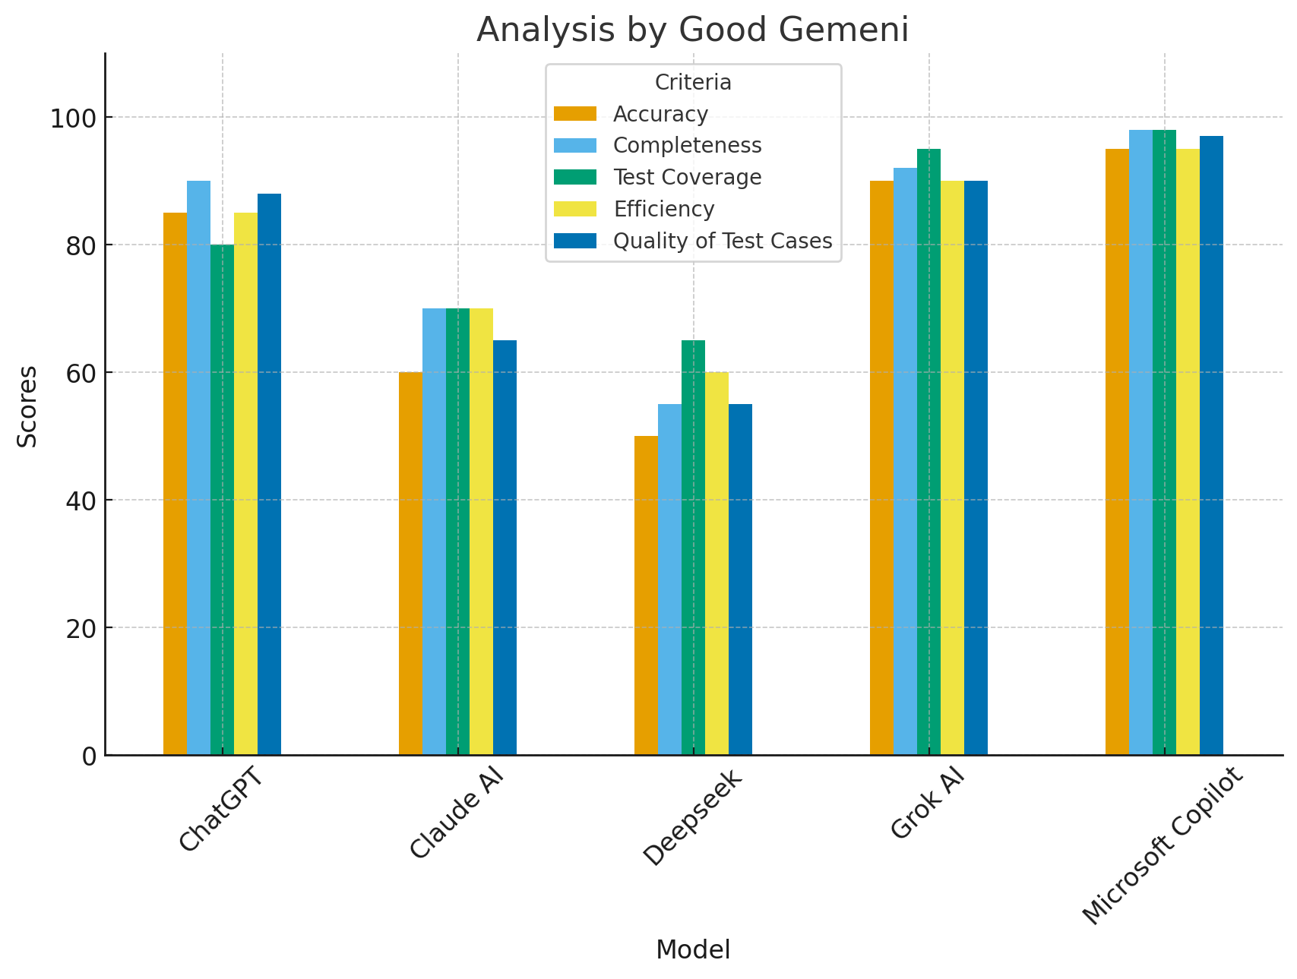
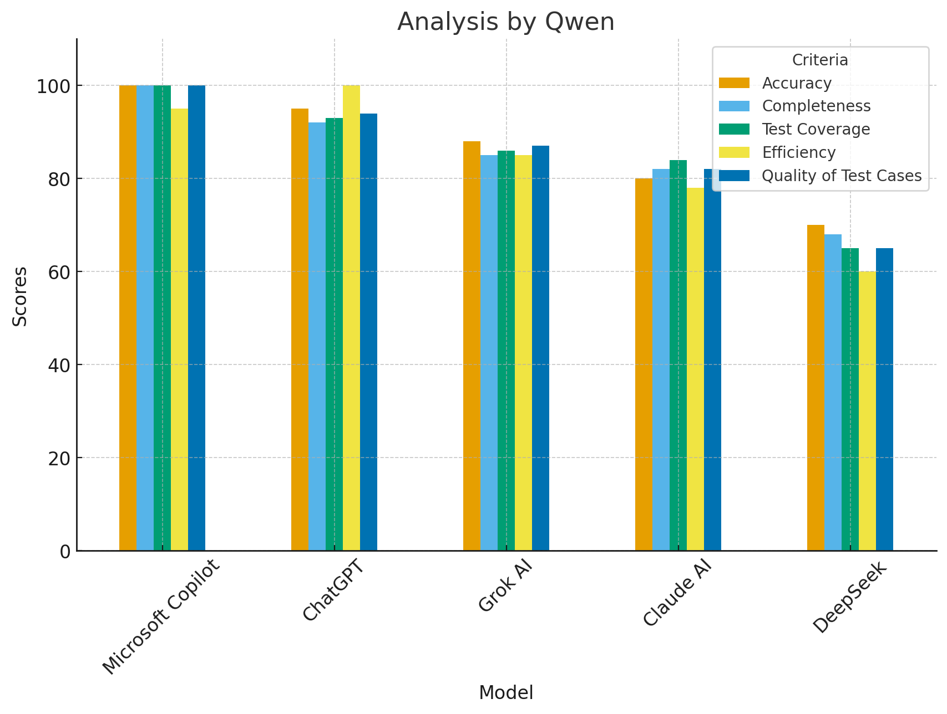
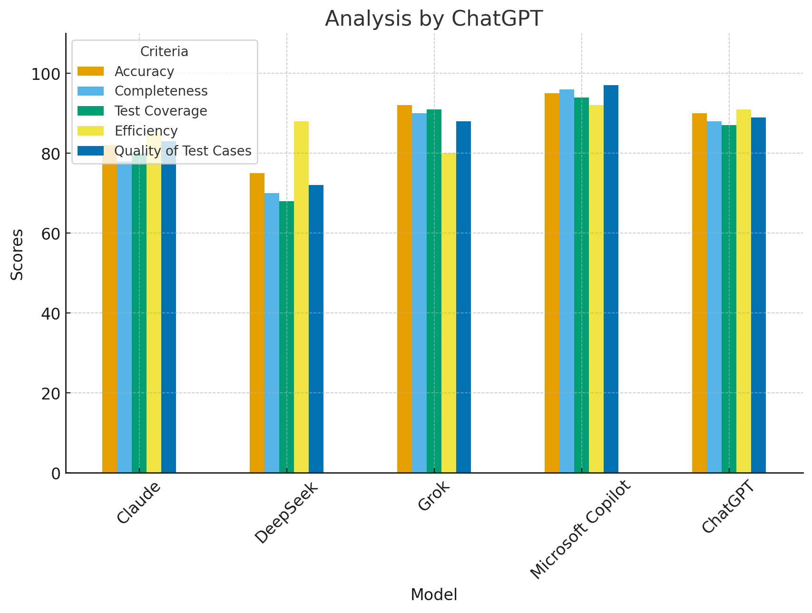
Findings
Based on the AI analysis, Microsoft Copilot initially appeared to be the best performer. However, after a detailed manual review, this conclusion did not hold true.
Comparison
- ChatGPT: Generates all test cases in a single, well-structured document with comprehensive details. Its outputs also provide traceability, which strengthens reliability.
- Grok: Presents test cases in a modular format that is easy to understand and follow, offering good clarity and structure.
- Microsoft Copilot: Strong in automated analysis, but upon manual review, it fell short compared to ChatGPT and Grok.
Final Verdict
Both ChatGPT and Grok are strong performers, but ChatGPT is the overall winner. It offers detailed coverage, clear structure, and valuable traceability, making it the most practical and effective choice.

